Journey’s Reading – Miss Tobias’ Class

The instructions below will guide you through signing in to your online text.

1. Please visit this site:
www-k6.thinkcentral.com

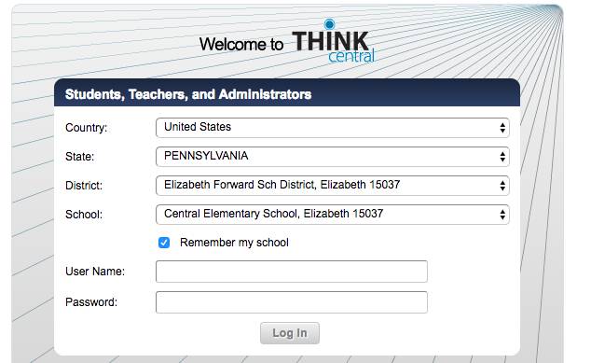
2. Fill in all demographics:
(Check the box to save them.)

3. The student username and password are the same for both. It is your student ID Number.
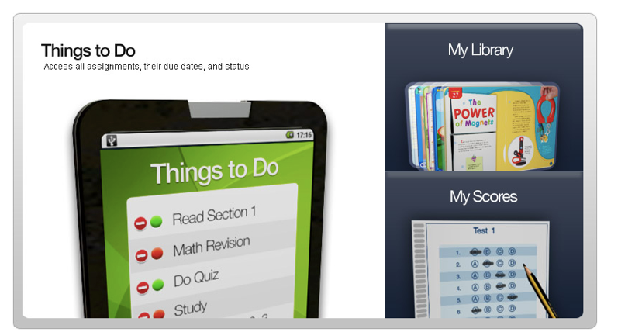
4. Once logged in, click My Library.

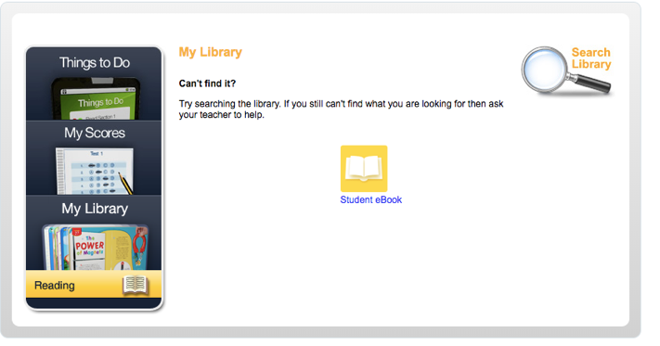
5. Click on Student eBook. Weekly Stories can be found by using the Table of Contents.

